**TABLE OF**

**CONTENTS**

* About the System
* Scope and Limitation of the Study
* Technical Background

Hardware Specification

Software Specification

* System Analysis and Design

System Overview

System Architecture

* System Output
* Recommendations

**EXECUTIVE**

**SUMMARY**

Mangyan Translator is an innovative online platform designed to support the preservation and accessibility of the Hanunó'o Mangyan language. It allows users to translate Hanunó'o text into English or Tagalog, understand the traditional script, and learn more about the Mangyan alphabet and culture.

The system bridges communication gaps and promotes cultural appreciation by providing a reliable tool for students, teachers, researchers, and indigenous community members. With real-time translation and access to the Hanunó'o alphabet, the system also encourages education and awareness of this indigenous language.

This project reflects a commitment to cultural inclusion and digital preservation, enabling future generations to study and respect the rich heritage of the Mangyan people.

**ABOUT THE**

**SYSTEM**

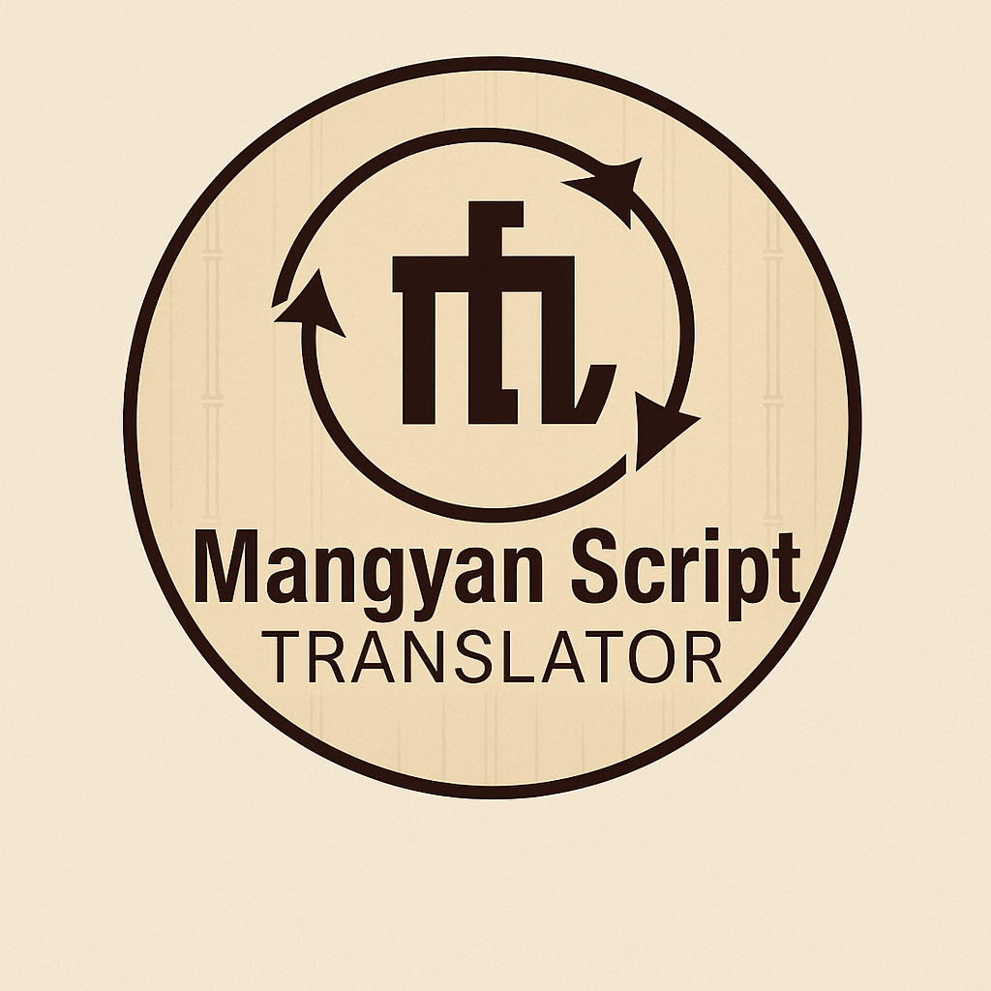

The Mangyan Translation System is an online tool developed to help users translate Hanunó'o Mangyan text into Tagalog or English. The system also features the Hanunó'o script and its corresponding alphabet, allowing users to learn and understand the structure of the language.

Users can input Hanunó'o words or phrases, and the system will return the equivalent meaning in the selected language. The system is educational, user-friendly, and accessible to people of all ages.

**SCOPE AND**

**LIMITATION OF THE**

**STUDY**

The Mangyan script translation system targets the Hanunuo in Oriental Mindoro, translating Surat Mangyan to preserve culture. It operates in areas like Mansalay but is limited by low script literacy and poor internet access. The system excludes other Mangyan scripts and faces resource constraints. Cultural sensitivity is critical for effective implementation. Community input ensures translation accuracy.

**TECHNICAL**

**BACKGROUND**

### **The Mangyan Translation System provides a fast, efficient, and digital way to translate indigenous text while promoting cultural awareness.**

### **Hardware Specifications**

The table below shows the **minimum** and **recommended** specifications of the laptop used in the development of the system.

| **Hardware Component** | **Minimum Specification** | **Recommended Specification** |
| --- | --- | --- |
| Laptop | Windows 7, 64-bit, 100GB free space | Windows 10, 64-bit |
| Hard Drive | 500GB (free space) | 500GB (free space) |
| Processor | Intel Pentium Dual-Core CPU | Intel Core i5 / i7 |
| Memory (RAM) | 2GB | 4GB or higher |
| Screen Resolution | 1280 x 720 pixels | 1366 x 768 pixels |
| Motherboard | AIO Motherboard 76dyp | AIO Motherboard 76dyp |

| **Hardware Component** | **Minimum Specification** | **Recommended Specification** |
| --- | --- | --- |
| Touchscreen Monitor/Kiosk | Intel J1900 2.0GHz (i3) | Intel J1900 2.0GHz (i3/i5/i7 Optional) |
| Hard Drive | 500GB | 500GB |
| Processor | Intel Dual-Core | Intel i5 / i7 |
| Memory (RAM) | 4GB | 4GB to 8GB |

The table below illustrates the **minimum** and **recommended** touchscreen monitor/kiosk specifications used in the system

### **Software Specifications**

The table below shows the **minimum** and **recommended** software specifications used in the system.

| **Software Component** | **Minimum Specification** | **Recommended Specification** |
| --- | --- | --- |
| Operating System | Windows 10, 64-bit | Windows 10, 64-bit |
| Database | XAMPP, version 7.3.31 | XAMPP, version 8.0.8 |
| Source Code Editor | Sublime Text Build 4121 | Sublime Text Build 4142 |
| Web Browser | Google Chrome 90.0.4430 | Google Chrome 113.0 |

**SYSTEM ANALYSIS & DESIGN**

**OVERVIEW**

### *****System Overview*****

Upon accessing the website, users can select the input language (Hanunó'o) and the output language (English or Tagalog). A text box is provided where users can type or paste the Hanunó'o script. Once submitted, the translated text appears below. Users may also access a visual guide to the Hanunó'o alphabet, including each character’s pronunciation and Latin equivalent. This is useful for learners or educators seeking to study the script.

The system has three main users:

1. General User – Can input text and get translations.
2. Administrator – Manages the translation database and system settings.
3. Contributor/Researcher – May suggest new word entries or corrections

*****System Architecture*****

The Mangyan Translation System Architecture is designed as a web-based platform that facilitates the translation of Hanunó'o Mangyan text into either Tagalog or English. At the core of the system is the user-friendly web interface where users can input Hanunó'o script and select their desired output language. Once submitted, the input is processed by a translation engine that identifies each character and applies linguistic rules from a built-in database. This engine interacts with a structured dictionary containing Hanunó'o words and their equivalent meanings in Tagalog and English. After processing, the translated result is displayed back to the user through the interface. Supporting this process is an administrator module that manages the database, updates translation entries, and oversees system functionality. This layered architecture ensures efficient data flow, accurate translations, and ease of maintenance while promoting cultural preservation and accessibility of the indigenous Hanunó'o language.

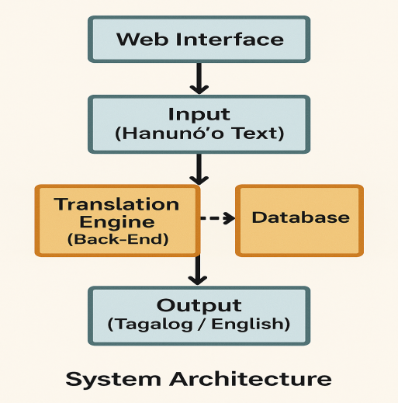

**SYSTEM**

**OUTPUT**

**Home Page**

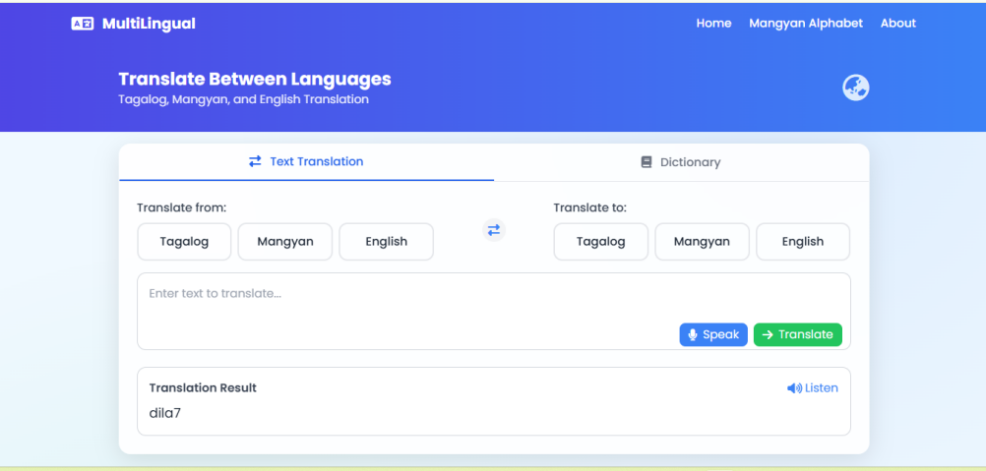

The User Translation Page provides a text-based translator for Tagalog, Mangyan, and English. Users can input or speak text, select source and target languages, and view instant translation results with options to listen to the output.

**Mangyan Alphabet**

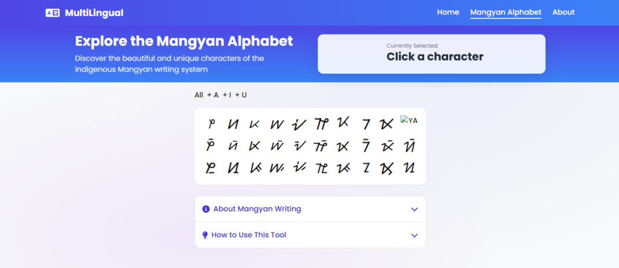

The Mangyan Alphabet Page allows users to explore the indigenous Mangyan script, offering a visual interface to interact with characters and learn more about their usage and meaning. It includes dropdowns to explain the writing system and guide users on how to use the tool effectively.

**Admin Page**

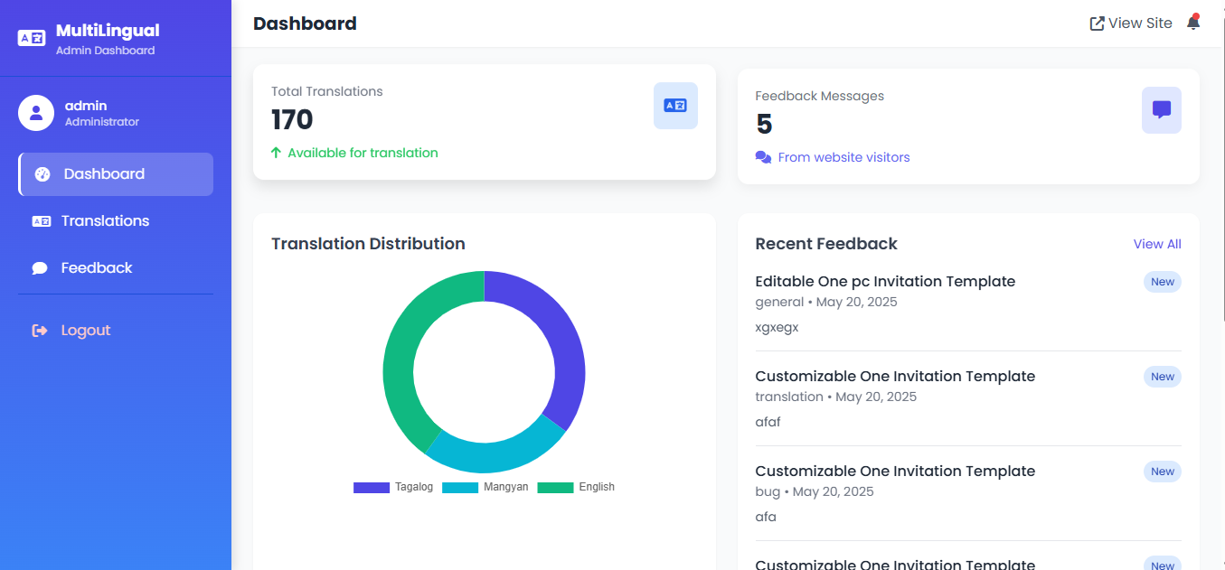

The Admin Dashboard of the MultiLingual system displays key statistics such as total translations, translation distribution (Tagalog, Mangyan, English), and feedback messages from users. Admins can easily manage translations and monitor recent feedback submissions for quality control and continuous improvement.

**Recommendation**

1. The Mangyan Translation System is recommended for continued use in schools and academic institutions to promote cultural preservation and support indigenous language education
2. A mobile-responsive version of the platform should be developed to ensure accessibility across different devices, especially for users in remote or rural areas.
3. Incorporating a dictionary feature that includes definitions, usage examples, and audio pronunciation would enhance the learning experience.
4. Adding user tutorials or guided walkthroughs would help first-time users understand how to use the translator and explore the Mangyan alphabet effectively.
5. Collaboration with linguists, educators, and local Mangyan communities is highly recommended to validate translations and enrich the database with accurate and culturally relevant entries.
6. The system should include offline capabilities or a downloadable version to cater to users with limited or no internet access.
7. To improve engagement and learning, gamification elements such as quizzes or learning milestones could be integrated into the alphabet exploration section.
8. A feedback and suggestion module should be enhanced or expanded to gather insights from users for continuous system improvement.
9. Future enhancements should include text-to-speech and speech-to-text features in all supported languages to improve accessibility and inclusivity.
10. For long-term sustainability, the system should consider integration with educational platforms and government language preservation initiatives to ensure widespread adoption and support.

**DEVELOPERS/TEAM**

RODRIGUEZ, KIAN A MELCHOR, MAUREEN

CATAPANG, MARIA ANGELA N.